 COSC 2320
Name: _________________ Terminal #__

Estimated Hours 1
Actual Hours

TA (Textual Analysis) for UML MVC CLASS Diagram MODEL
Programming Assignment 2:
(10 points)
(Due date found in the COSC 2320 BB Calendar!)
You must use Microsoft WORD program. Insert the TEMPLATEs for Class, Attribute, and Method in this Requirements Document.

Please have Step 1, 2, 3, 4, and 5 in this order.

Requirements Analysis: Construct the UML MVC Class Diagram MODEL

QUEUE - Linked Implementation - Ticket System Application
ProgrammingAssignment2 APPLICATION

XY Airlines (XYA) is considering redesigning its ticket counters for airline passengers. The company would like to have two separate waiting lines: one for regular customers and one for frequent flyers. Assuming there is only one ticket agent available to serve all passengers, the company would like to determine the average waiting time for both types of passengers using various strategies for taking passengers from the waiting lines (see figure below). A “democratic” strategy for serving passengers would be to take turns serving passengers from both lines (that is, one frequent flyer, one regular passenger, one frequent flyer, and so on). Another “democratic” strategy would be to serve the passenger who has been waiting in line the longest, but this would be the same as having a single queue. (Why?) An “elitist” strategy would be to serve any frequent flyer waiting in line before serving the regular passengers.


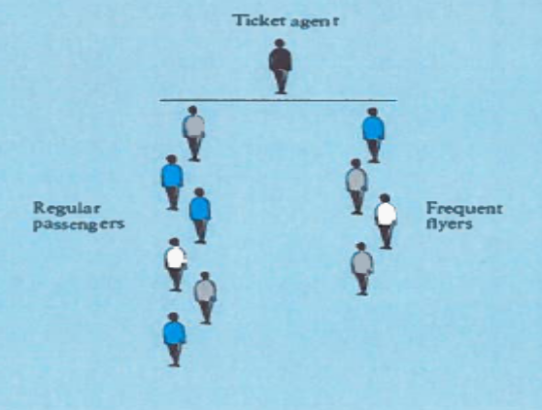

Running a computer simulation is a good way to investigate the effect of different serving strategies. To run a computer simulation, we must keep track of the current time by maintaining a clock that is set to an initial time of zero. This clock will increase by one time unit until the simulation is finished. During each time interval, one or more of the following events may occur.
1. A new frequent flyer passenger arrives in line.
2. A new regular passenger arrives in line.
3. The ticket agent finishes serving a passenger and begins to serve a passenger from the frequent flyer line.
4. The ticket agent finishes serving a passenger and begins to serve a passenger from the regular passenger line.
5. The ticket agent is idle because there are no passengers in either line to serve.

The purpose of running the simulation is to determine statistics about the waiting times for frequent flyers and for regular passengers. In addition to the priority given to frequent flyers, the waiting times depend on the arrival rate of each type of passenger (number of passengers arriving per minute) and the time required to serve a passenger. There are different arrival rates for each kind of passenger. In addition to statistics on waiting times, we can display a minute- by- minute trace of events occur-ring during each minute of the simulation. We can simulate different serving strategies by introducing a simulation variable frequent_ flyer_ max, which must be a positive integer. This will represent the number of consecutive frequent flyer passengers served between regular passengers. When frequent_ flyer_ max is 1, every other passenger served will be a regular passenger (the “democratic” strategy). When frequent_flyer_max is 2, every third passenger served will be a regular passenger. When frequent_ flyer_ max is a very large number, any frequent flyer passenger will be served before a regular passenger (the “ elitist” strategy).

Assume that the “Programming Assignment 2 Data.txt” will contain the following (in RED are some samples):
Expected number of frequent flyer arrivals per hour: 15
Expected number of regular passenger arrivals per hour: 30
Enter the maximum number of frequent flyers served between regular passengers 5
Enter the maximum service time in minutes 4
Enter the total simulation time in minutes 10
Display minute-by-minute trace of simulation (Y or N) Y
Create a ProgrammingAssignment1.java that contains the main method.
PLEASE DO NOT INCLUDE THESE PAGES AS YOUR DELIVERABLES! This is just for your use. Please have Step 1, then 2, etc. order in your deliverables.

UML LANGUAGE THAT MUST BE USED FOR TEXTUAL ANALYSIS!!!

UML MVC CLASS DIAGRAM MODELING:

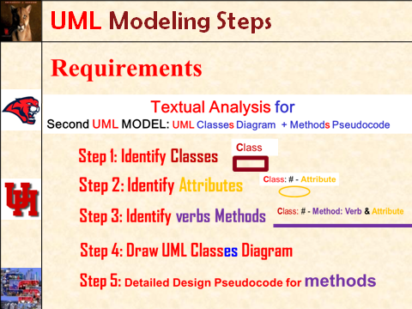

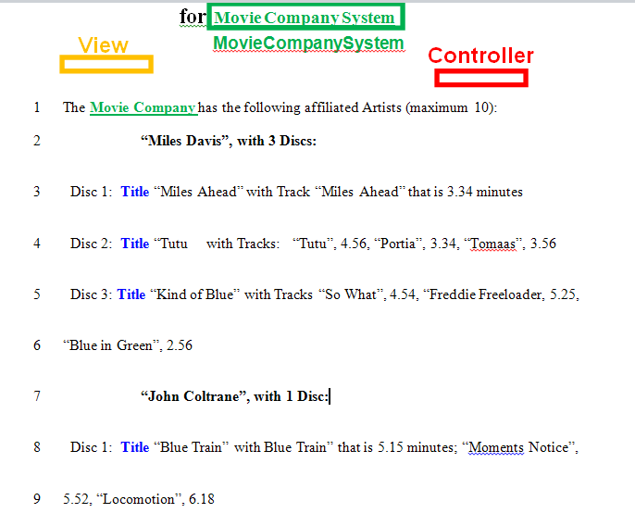
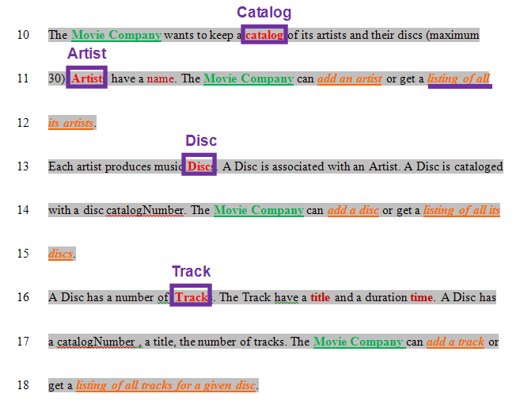
SEMANTICS: 
Class is a (first letter Upper Case) Noun.

TEMPLATE:
Class

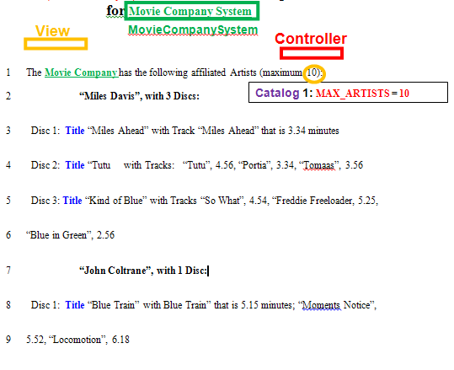
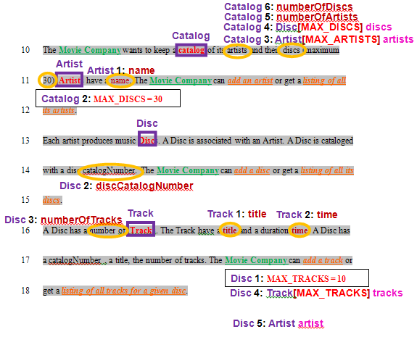
SEMANTICS: 
# - Attribute is a data Attribute for the Class and # counts Attributes for the Class

TEMPLATE:
Class: # - Attribute

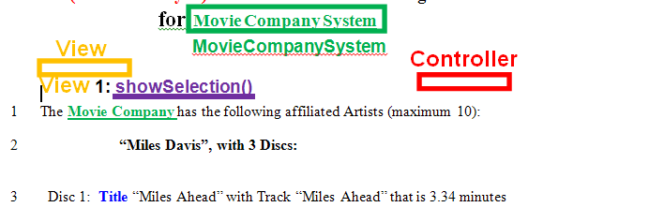
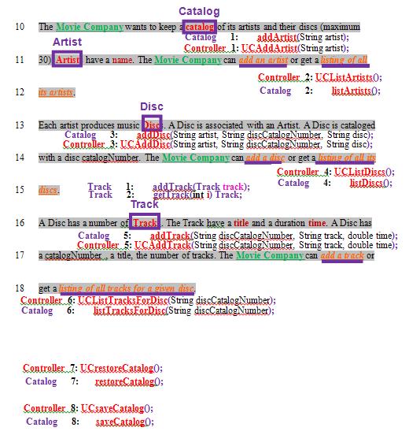
SEMANTICS: 
Method # is an operation on an Attribute for the Class and & is concatenation

TEMPLATE:
Class: # - Method: Verb & Attribute

